Term Project

Quantum Mechanics

Ayush Nema (DAA)

Sonali Gupta (DNAP)

Suriya Selvarajan (DTP)

Vibin Narayanan V (DTP)

Vivek Singh (DTP)



1

The quantum pendulum hamiltonian is given by:

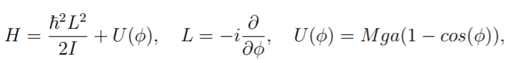

To solve this we have used finite differences to estimate the infinitesimal differences which are generated by the double derivative appearing in hamiltonian.

We have taken a (N-1)\*(N-1) matrix with N=1000

The plot shows that the system starts to exhibit double degeneracy after N= 47.

(The details of the tridiagonal matrix method are shown in question 4(a).)

The output of the program is -

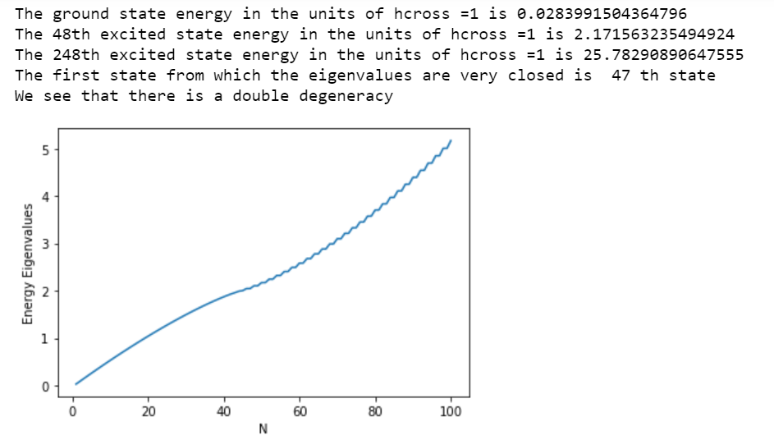

2

We have been given the potential:

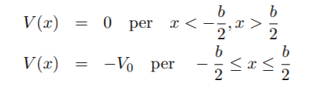

The matrix elements of the Hamiltonian for the potential part are given by:

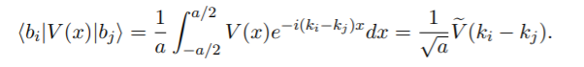

And the matrix elements of the Hamiltonian for the kinetic part are given by:

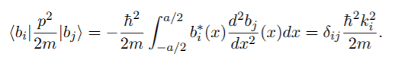

The former can be explicitly calculated:

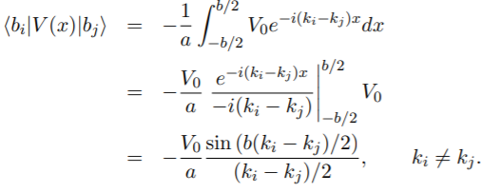

The case ki = kj must be separately treated, yielding:

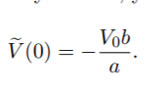

We have entered these matrix elements and have calculated its eigenvalues for different values of N to show how the result converges.

Output:

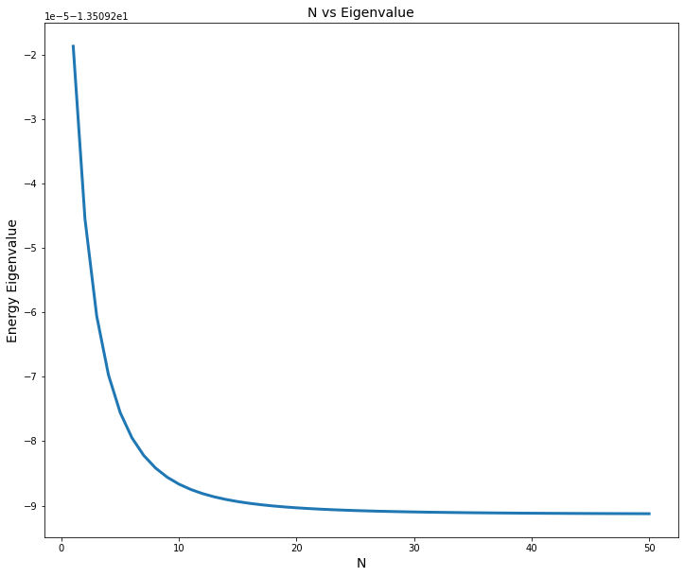

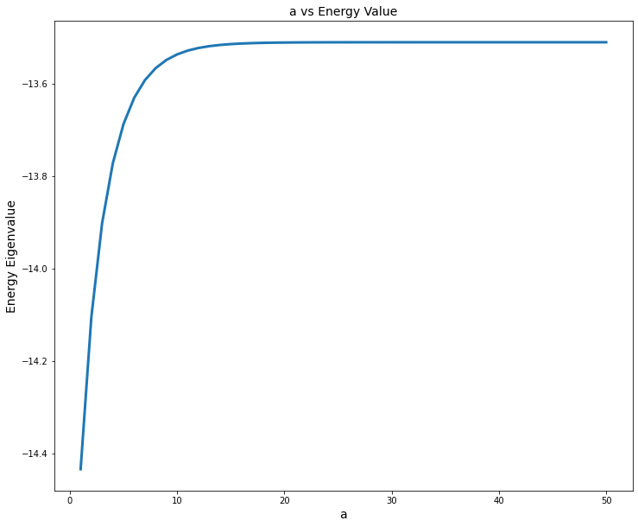

3

The potential in the problem is:

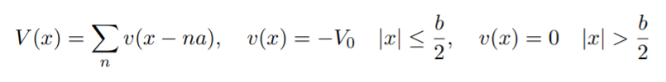

We again go to the plane wave basis just like in question number 2.

It is convenient to consider plane waves up to a maximum (cutoff) kinetic energy:

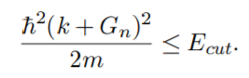

The matrix elements of the Hamiltonian are:

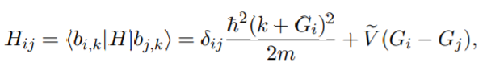

Where,V tilda is the fourier transform of the potential as done in question number 2.

We then obtain the energy eigenvalues by making the discrete N by N matrix.

Output:

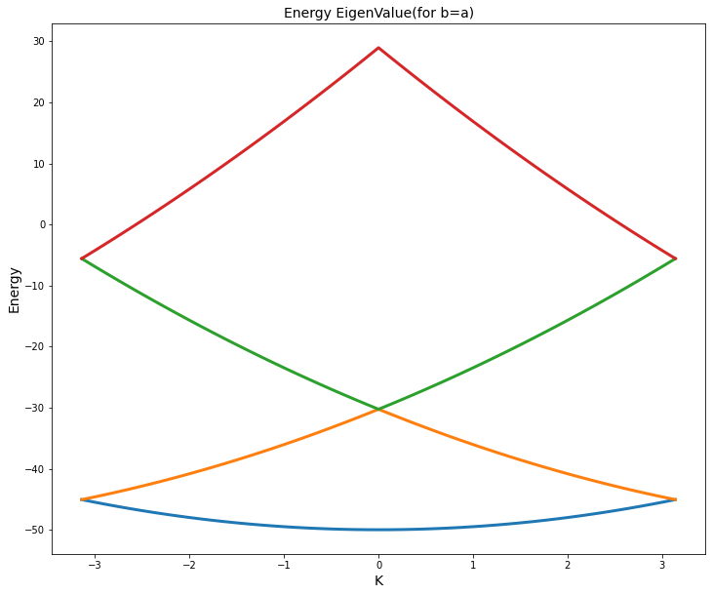

4

In order to solve Schrodinger equation for any potential inside rigid boundaries, we can construct a tridiagonal hamiltonian matrix by using the difference equations and then find the eigenvalues and eigenvectors of corresponding Schrdinger equation

We have-

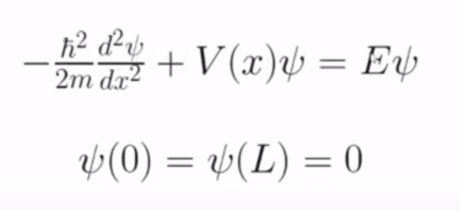

Let y=x/l in order to simplify the numerical analysis. Substituting this into the equation, we get

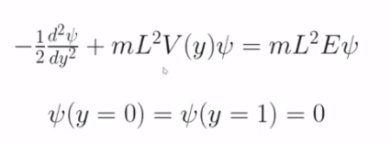

The difference equations are a good approximation of differentiations and result in recursions which end at the given boundary conditions at y=0 and y=1.

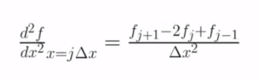

Substituting this in our equation, we get-

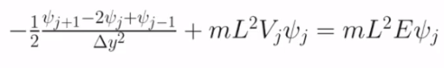

Which, after some simplification, leads to-

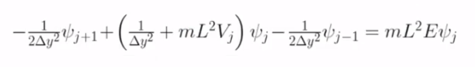

The above recursion system leads to a system of N+1 linear equations with given boundary conditions.

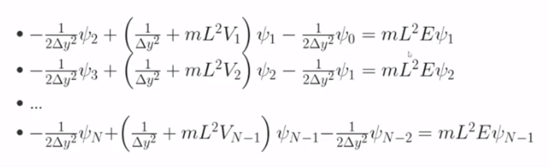

which can be written in a matrix form (excluding the initial and final rows at boundaries)-

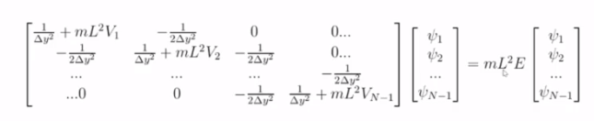

The eigenvalues and eigenvectors of the above formed tridiagonal matrix can easily be obtained using scipy.eigh.tridiagonal function available in python scipy library for any potential function.

For given potential,

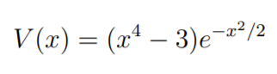

The code outputs the wave functions for ground and higher order states as-

